**Creating Microservices for account and loan**

**Account Microservice**

package com.cognizant.account.Controller;

import org.springframework.web.bind.annotation.GetMapping;

import org.springframework.web.bind.annotation.PathVariable;

import org.springframework.web.bind.annotation.RestController;

@RestController

public class AccountController {

@GetMapping("/accounts/{number}")

public Account getAccountDetails(@PathVariable String number) {

return new Account(number, "savings", 234343);

}

record Account(String number, String type, double balance) {}

}

**Output:**

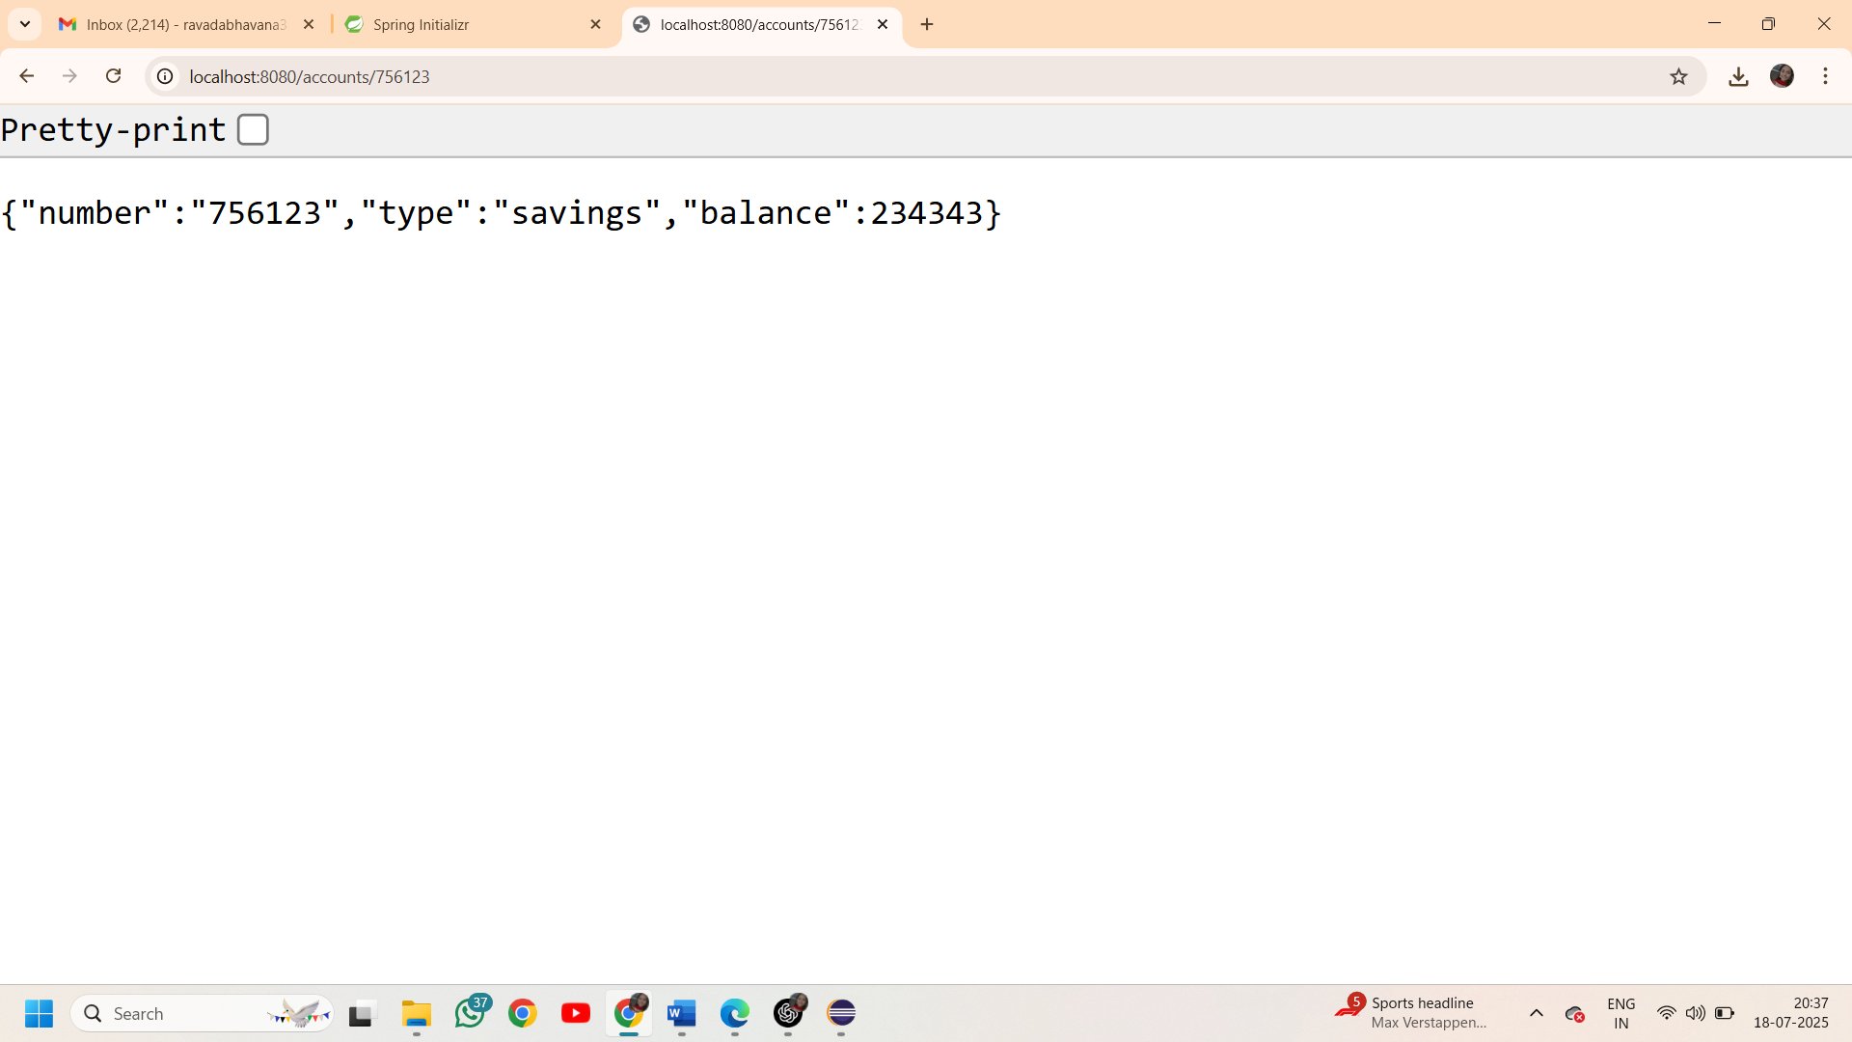

**Loan Microservice**

package com.cognizant.loan.Controller;

import org.springframework.web.bind.annotation.GetMapping;

import org.springframework.web.bind.annotation.PathVariable;

import org.springframework.web.bind.annotation.RestController;

@RestController

public class LoanController {

@GetMapping("/loans/{number}")

public Loan getLoanDetails(@PathVariable String number) {

return new Loan(number,"car",400000,3258,18);

}

record Loan(String number,String type,int loan,int emi,int tenure) {}

}

**Output:**

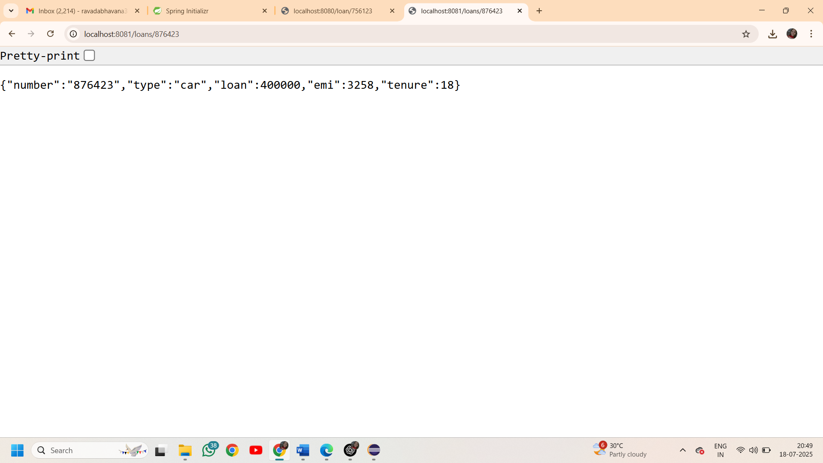

**Additional Important hands-on:**

**Create Eureka Discovery Server and register microservices**

**Create and launch eureka discovery server**

package com.cognizant.eureka_discovery_server;

import org.springframework.boot.SpringApplication;

import org.springframework.boot.autoconfigure.SpringBootApplication;

import org.springframework.cloud.netflix.eureka.server.EnableEurekaServer;

@SpringBootApplication

@EnableEurekaServer

public class EurekaDiscoveryServerApplication {

public static void main(String[] args) {

SpringApplication.*run*(EurekaDiscoveryServerApplication.class, args);

}

}

**->I have registered for account and loan REST API to eureka discovery by making use of @EnableDiscoveryClient annotation**

**greet-service**

package com.cognizant.greet.Controller;

import org.springframework.web.bind.annotation.GetMapping;

import org.springframework.web.bind.annotation.RestController;

@RestController

public class GreetController {

@GetMapping("/greet")

public String sayHello() {

return "Hello World!";

}

}

**Output:**

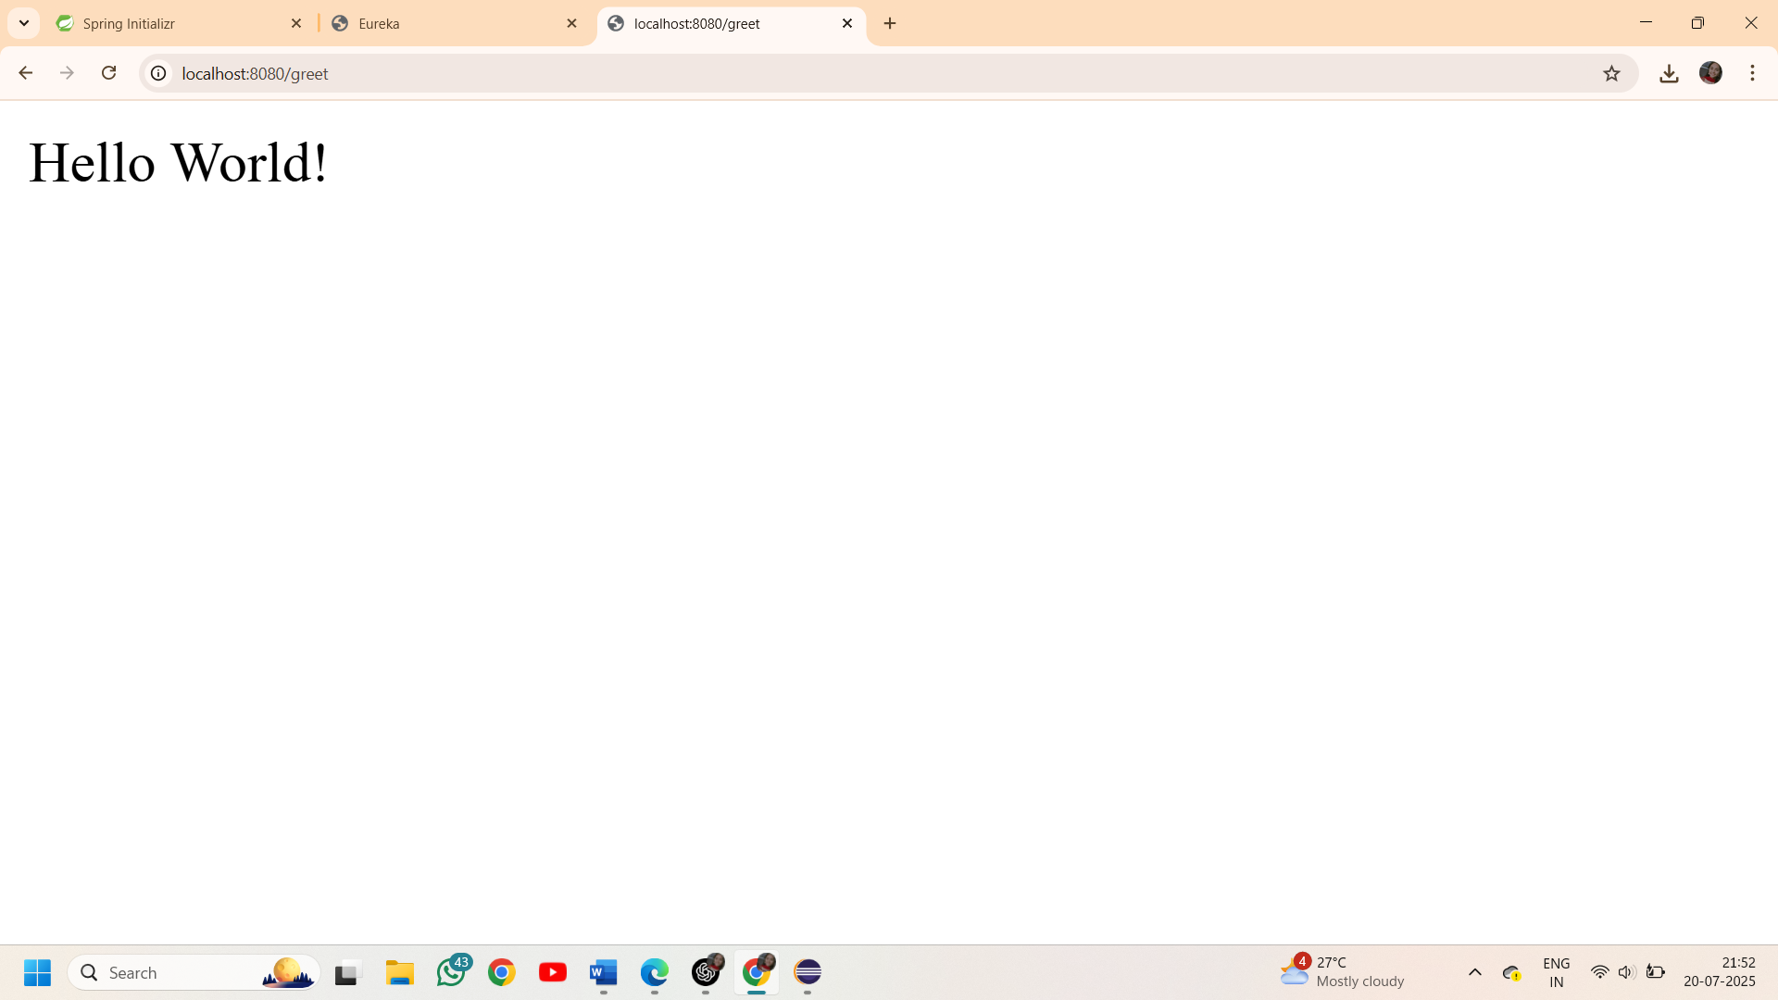

**Created another microservice “api-gateway”**

Eureka Server:

